Academic Colloboration Protocols ( ACP)
Flag | University | Scope | Country | Initiation Date
 | Kyungpook National University | Student and Staff Exchange | South Korea | 12.03.2009
 | Southeast University | Student and Staff Exchange | People’s Republic of China | 7.06.2010
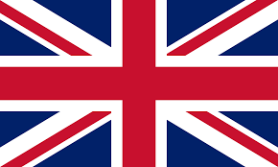 | Bournemouth University | Academic Cooperation | UK | 11.03.2009
 | Gdansk University | Common Journal Press | Poland | 29.01.2009
 | Hanyang University | Student and Staff Exchange | South Korea | 27.04.2012
 | Chungang University | Student and Staff Exchange | South Korea | 27.01.2014
 | Seoul University | Student and Staff Exchange | South Korea | 18.05.2015
 | Dong-a University | Student and Staff Exchange | South Korea | 26.06.2015
 | Shanghai International Business and Economics University (SUIBE) | Student and Staff Exchange | People’s Republic of China | 30.06.2014
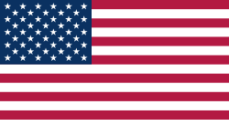 | Michigan State University (MSU) | Student and Staff Exchange | USA | 06.03.2014
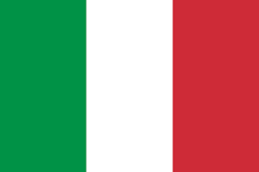 | Messina University | Academic Cooperation | Italy | 16.04.2014
 | SUNY –Albany Campus | Academic Cooperation  and Double Degree | USA | 10.12.2014
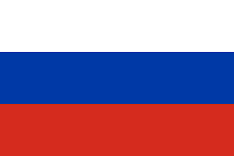 | Voronezh State University | Student and Staff Exchange | Russia | 17.05.2018
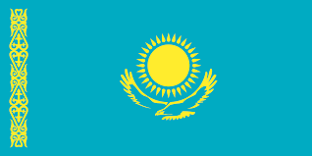 | Eurasian National University | Student and Staff Exchange | Kazakhstan | 12.01.2021
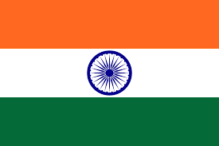 | Sharda University | Student and Staff Exchange | India | 27.08.2021
 | Shanghai Normal University | Student and Staff Exchange | People’s Republic of China | 06.01.2022  (valid for 5 years)

