Faculty of Business Erasmus Agreements
 | Flag | University Name | Erasmus ID | Country
1 | 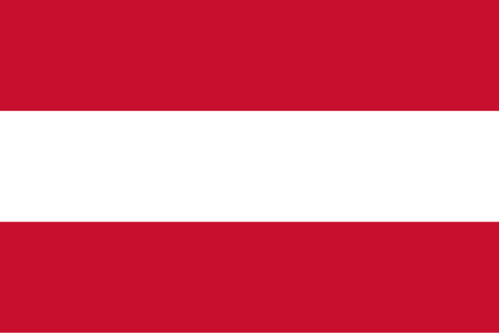 | IMC UNIVERSITY OF APPLIED SCIENCES | A KREMS 03 | AUSTRIA
2 |  | UNIVERSITY OF APPLIED SCIENCES UPPER AUSTRIA | A WELS 01 | AUSTRIA
3 | 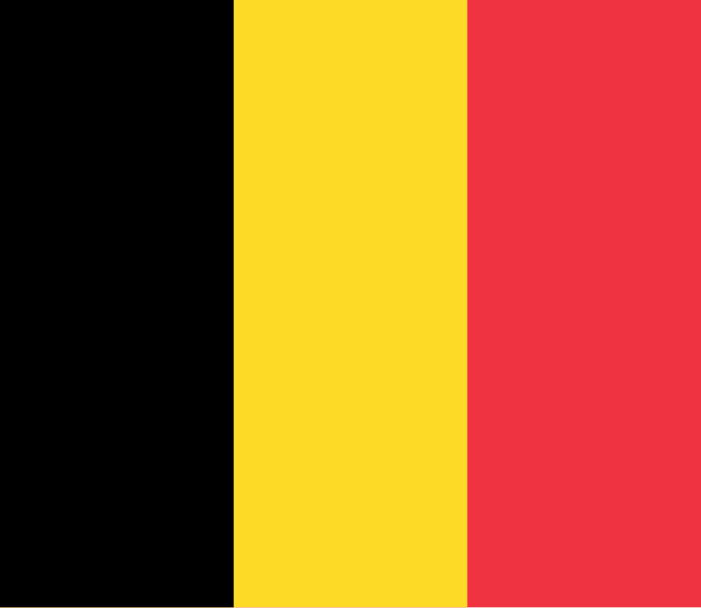 | ODISEE VZW | B BRUSSEL 48 | BELGIUM
4 |  | EPHEC UNIVERSITY COLLEGE | B BRUXEL 82 | BELGIUM
5 |  | ARTEVELDE UNIVERSITY COLLEGE GHENT | B GENT 39 | BELGIUM
6 | 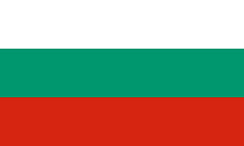 | UNIVERSITY OF NATIONAL AND WOLD ECONOMY | BG SOFIA 03 | BULGARIA
7 | 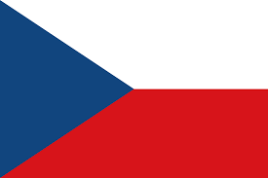 | BRNO UNIVERSITY OF TECHNOLOGY | CZ BRNO 01 | CZECH
8 |  | UNIVERSITY OF HRADEC KRALOVE | CZ HRADEC 01 | CZECH
9 |  | MORAVIAN BUSINESS COLLEGE OLOMOUC | CZ OLOMOUC 03 | CZECH
10 |  | TOMAS BATA UNIVERSITY IN ZLIN | CZ ZLIN 01 | CZECH
11 | 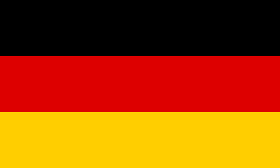 | AACHEN UNIVERSITY OF APPLIED SCIENCES | D AACHEN 02 | GERMANY
12 |  | UNIVERSITY OF AUGSBURG | D AUGSBUR 01 | GERMANY
13 |  | THD-TECHNISCHE HOCHSCHULE DEGGENDORF | D DEGGEND 01 | GERMANY
14 |  | ISM DORTMUND | D DORTMUN 04 | GERMANY
15 |  | DRESDEN UNIVERSITY OF APPLIED SCIENCES | D DRESDEN 01 | GERMANY
16 |  | FRIEDRICH ALEXANDER UNIVERSITAT ERLANGEN | D ERLANGE 01 | GERMANY
17 |  | ALBERT-LUDWIGS UNIVERSITAT FREIBURG | D FREIBUR 01 | GERMANY
18 |  | HOCHSCHULE HEILBRONN | D HEILBRO 01 | GERMANY
19 |  | KOBLENZ UNIVERSITY OF APPLIED SCIENCES | D KOBLENZ 01 | GERMANY
20 |  | COLOGNE BUSINESS SCHOOL | D KOLN 12 | GERMANY
21 |  | NORDHAUSEN UNIVERSITY OF APPLIED SCIENCES | D NORDHAU 01 | GERMANY
22 |  | BSP BUSINESS & LAW SCHOOL | D POTSDAM 04 | GERMANY
23 |  | UNIVERSITY OF HOHENHEIM | D STUTTGA 02 | GERMANY
24 |  | DUALE HOCHSCHULE BADEN-WURTTEMBERG VILLINGEN SCHWENNINGEN | D VILLING 02 | GERMANY
25 | 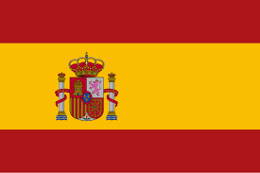 | UNIVERSIDAD DE OVIEDO | E OVIEDO 01 | SPAIN
26 |  | UNIVERSIDADE DE VIGO | E VIGO 01 | SPAIN
27 | 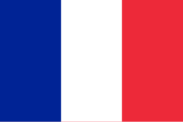 | INSTITUT D'ETUDES POLITIQUES DE BORDEAUX | F BORDEAU 37 | FRANCE
28 |  | UNIVERSITE DE SAVOIE | F CHAMBER 01 | FRANCE
29 |  | CLERMONT UNIVERSITY | F CLERMON02 | FRANCE
30 |  | UNIVERSITE LILLE 3 DROIT ET SANTE | F LILLE 103 | FRANCE
31 |  | UNIVERSITE CATHOLIQUE DE LILLE | F LILLE 11 | FRANCE
32 |  | UNIVERSITE CATHOLIQUE DE LYON | F LYON 10 | FRANCE
33 |  | IDRAC INTERNATIONAL SCHOOL OF MANAGEMENT | F LYON 112 | FRANCE
34 |  | ISTEC Business School | F PARIS 349 | FRANCE
35 | 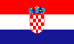 | UNIVERSITY OF DUBROVNIK | HR DUBROVN 01 | CROATIA
36 |  | BUSINESS SCHOOL PAR | HR RIJEKA 03 | CROATIA
37 |  | UNIVERSITY OF SPLIT | HR SPLIT 01 | CROATIA
38 |  | UNIVERSITY OF ZAGREB | HR ZAGREB 01 | CROATIA
39 |  | UNIVERSITY OF PECS | HU PECS 01 | HUNGARY
40 |  | KDJ | HU SZFVAR 01 | HUNGARY
41 | 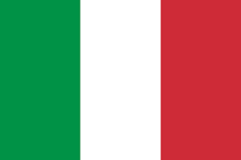 | UNIVERSITA DEGLI STUDI DI PADOVA | I PADOVA 01 | ITALY
42 |  | UNIVERSITA DEGLI STUDI DI PAVIA | I PAVIA01 | ITALY
43 |  | VILNIUS GEDIMINAS TECHNICAL UNIVERSITY | LT VILNIUS 02 | LITHUANIAN
44 |  | RIGA TECHNICAL UNIVERSITY | LV RIGA 02 | LITHUANIAN
45 | 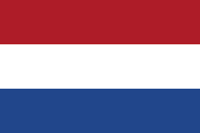 | NHTV BREDA UNIVERSITY OF APPLIED SCIENCES | NL BREDA 10 | HOLLAND
46 |  | FONTYS UNIVERSITY OF APPLIED SCIENCES | NL EINDHOV 03 | HOLLAND
47 |  | SAXION UNIVERSITY OF APPLIED SCIENCES (International Business School) | NL ENSCHED 03 | HOLLAND
48 |  | SAXION UNIVERSITY OF APPLIED SCIENCES (School of Commerce & Entrepreneurship) | NL ENSCHED 03 | HOLLAND
49 |  | HANZE UNIVERSITY OF APPLIED SCIENCES | NL GRONING03 | HOLLAND
50 |  | ROTTERDAM UNIVERSITY OF APPLIED SCIENCES | NL ROTTERD 03 | HOLLAND
51 |  | WINDESHEIM UNIVERSITY OF APPLIED SCIENCES | NL ZWOLLE05 | HOLLAND
52 | 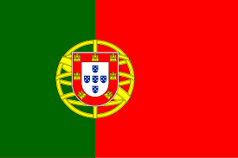 | POLYTECHNIC OF SETUBAL | P SETUBAL 01 | PORTUGAL
53 |  | BIALYSTOK UNIVERSITY OF TECHNOLOGY | PL BIALYST 01 | POLAND
54 |  | UNIVERSITY OF GDANSK | PL GDANSK 01 | POLAND
55 |  | GDANSK UNIV. OF TECH. | PL GDANSK 02 | POLAND
56 |  | UNIVERSITY OF ECONOMICS IN KATOWICE | PL KATOWIC 02 | POLAND
57 |  | KRACOW UNIVERSITY OF ECONOMICS | PL KRAKOW 04 | POLAND
58 |  | UNIVERSITY OF WROCLAW | PL WROCLAW 01 | POLAND
59 | 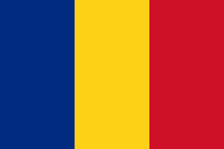 | 1 Dec. 1918 Univ. of ALBA JULIA | RO ALBAIU01 | ROMANIA
60 |  | UNIVERSITY OF BABEŞ BOLYAI | RO CLUJNAP 01 | ROMANIA
61 | 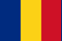 | UNIVERSITATEA OVIDIUS DIN CONSTANTA | RO CONS-TAN02 | ROMANIA
62 |  | HELSINKI METROPOLIA UNIVERSITY OF APPLIED SCIENCES | SF HELSINK 41 | FINLAND
63 |  | SATAKUNTA UNIVERSITY OF APPLIED SCIENCES | SF PORI 08 | FINLAND
64 |  | SEINAJOKI UNIVERSITY OF APPLIED SCIENCES | SF SEINAJO 06 | FINLAND
65 |  | LAUREA UNIVERSITY OF APPLIED SCIENCES | SF VANTAA 06 | FINLAND
66 | 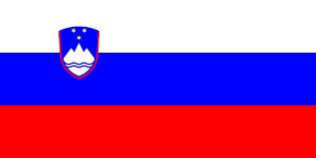 | UNIVERSITY OF LJUBLJANA | SI LJUBLJA 01 | SLOVENIA
67 |  | KDG Univ. of App. Sciences | B ANTWERP 59 | BELGIUM
68 |  | VILNIUS GEDIMİNO TECHNICAL UNIVERSITY | LT VILNIUS 02 | LITHUANIAN
69 |  | GEA COLLAGE FACULTY OF ENTRAPRENEURSHIP | SI PORTORO 02 | SLOVENIA

